* **Design Given Layout Using HTML And CSS.**

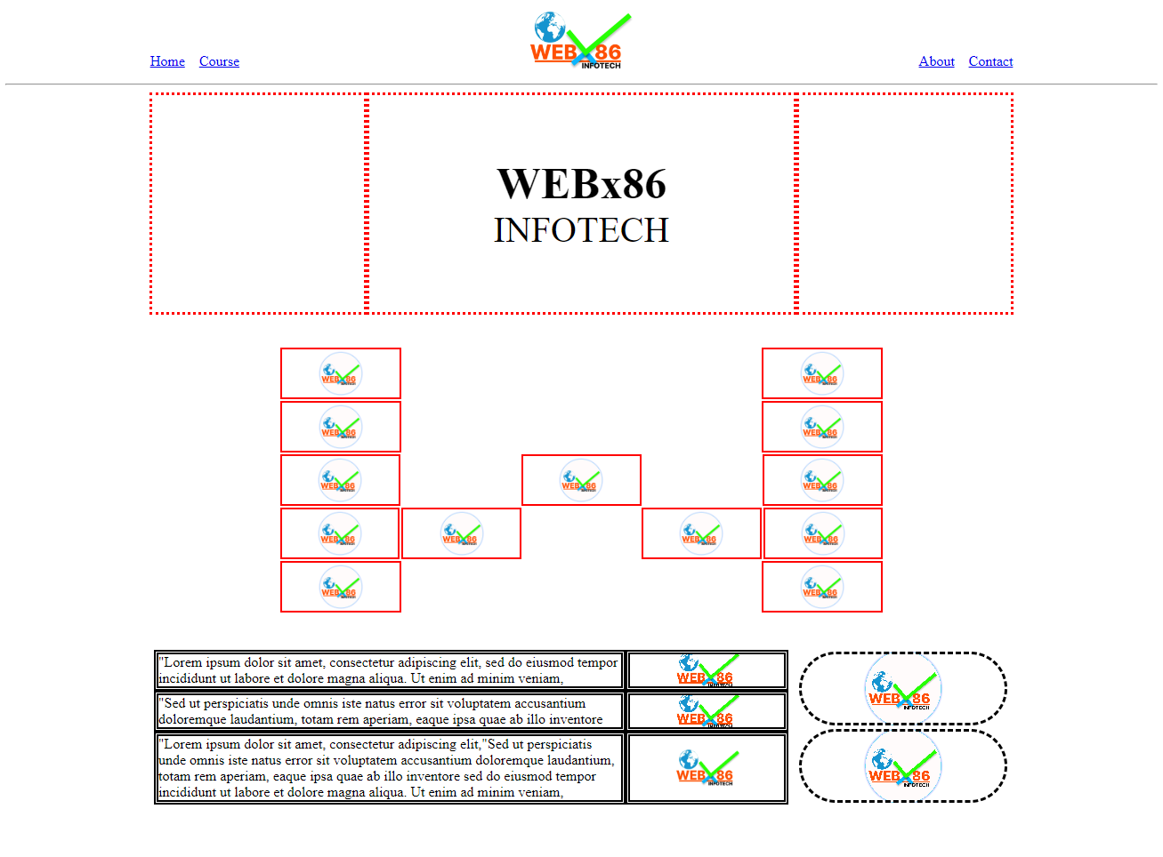

Note :

* Use Images from your own choice.
* Don’t use Flex or Grid.